[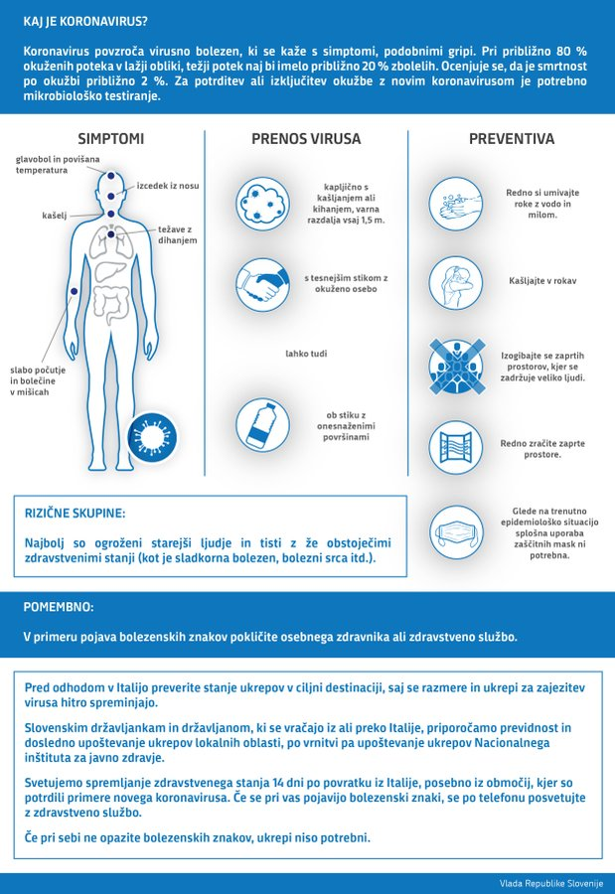](https://twitter.com/vladaRS/status/1231958206521511937/photo/1?ref_src=twsrc%5etfw|twcamp%5etweetembed|twterm%5e1231958206521511937&ref_url=https://www.had.si/blog/2020/02/25/koronavirus-in-ustvarjanje-izrednih-razmer-si-res-zelite-ziveti-v-konstantnem-strahu/)